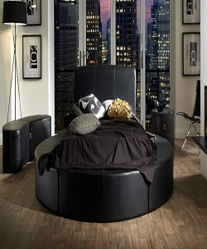

Bed

$522.87

Availability: In stock

Description

The ultra-modern Bed will transform an ordinary bedroom into the center of attention. This bed also accommodates UK standard size mattresses, so on worries about special mattress covers and sheets. with its curvaceous contours and spacious sleeping surface, the Bed evokes a tranquil oasis of calm and relaxation. The nature and design of this bed allows it to suit most modern bedrooms.